ClubSpark Booking Module – User Guide

Go to the Saxmundham Tennis Club website by clicking on the following link:
https://clubspark.lta.org.uk/SaxmundhamTennisClub
and sign in with your registered email and password.

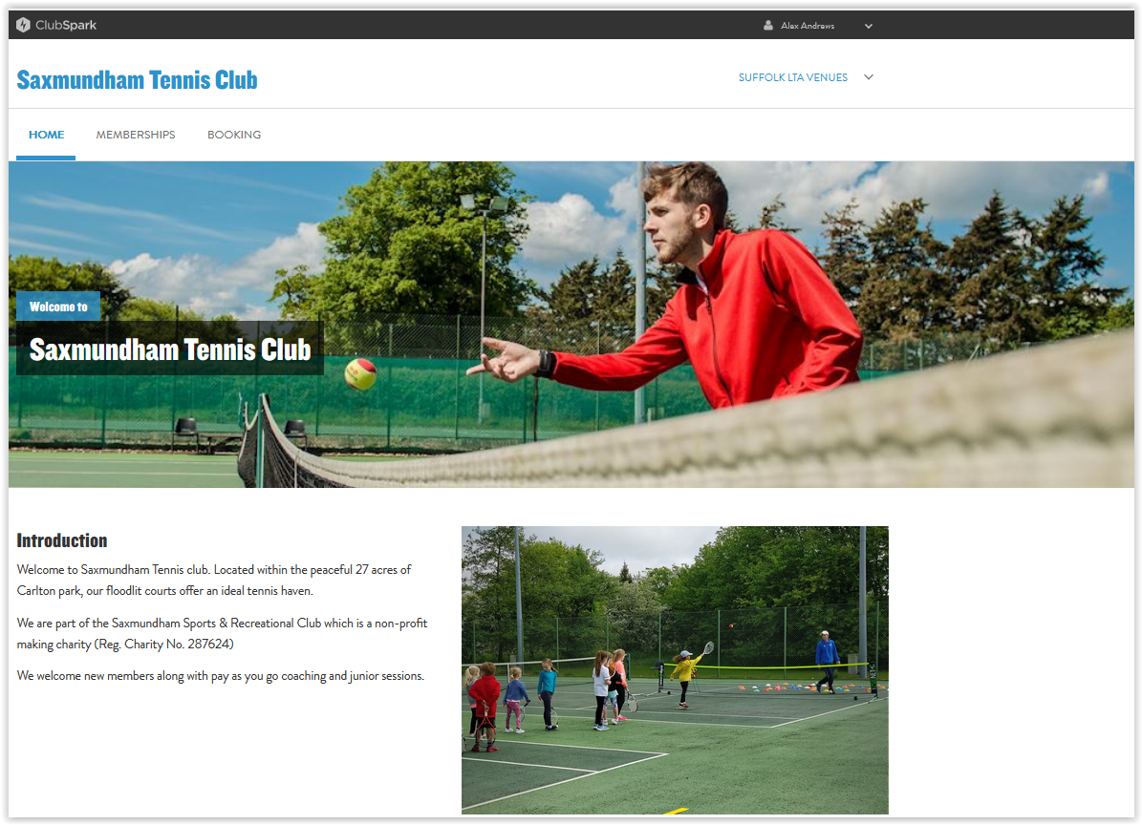

Click on the BOOKING tab

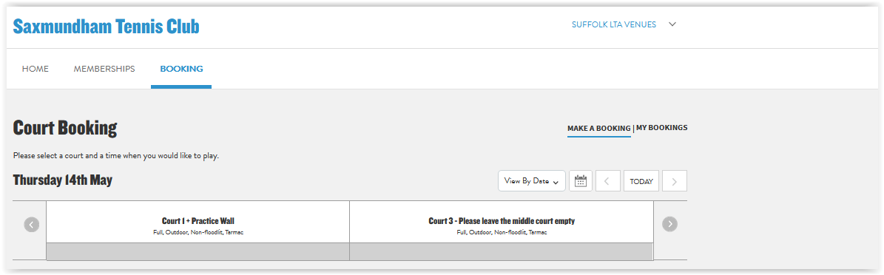

The Court Booking header screen is displayed showing the bookings for the current day.

The day can be advanced either by clicking on the Right Arrow next to Today
or by selecting a Date from the Calendar Icon

Bookings for the next seven days can be seen by court by selecting the View by Court in the drop down box next to the Calendar Icon 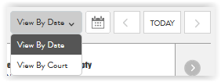

and selecting the court required from the drop down box for the Court required
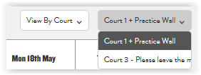
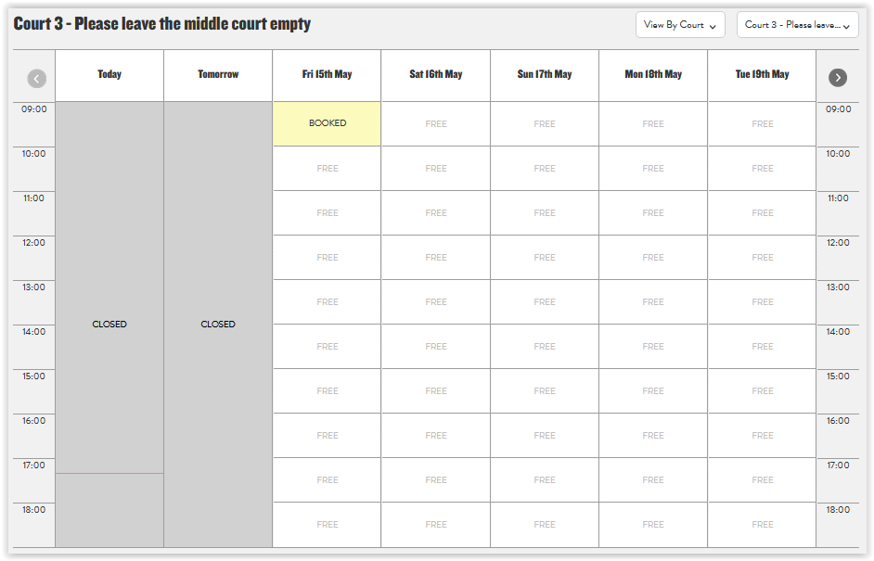

Bookings for the following seven days can be viewed by clicking on the Right Arrow in the top right column.

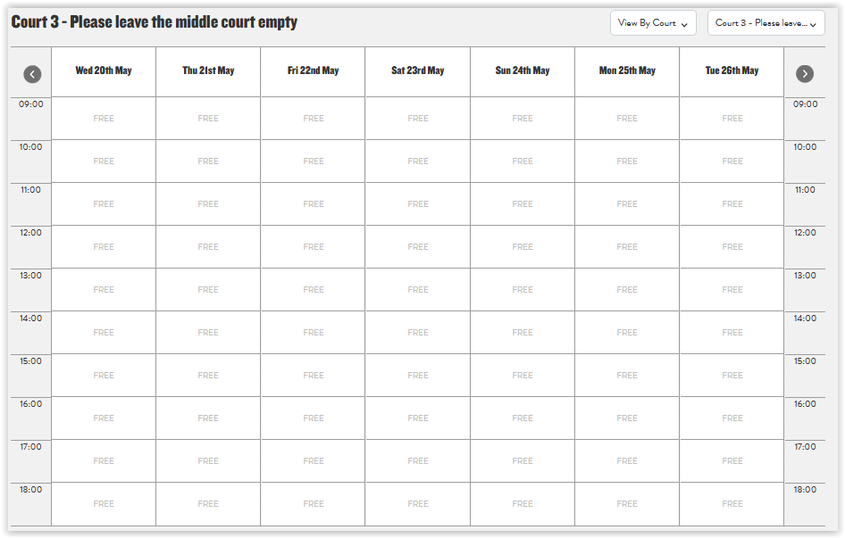

Although you will see if a court has been booked, the only other identifier is when Matt books a court for Coaching. You will however see your name against any session you have booked.

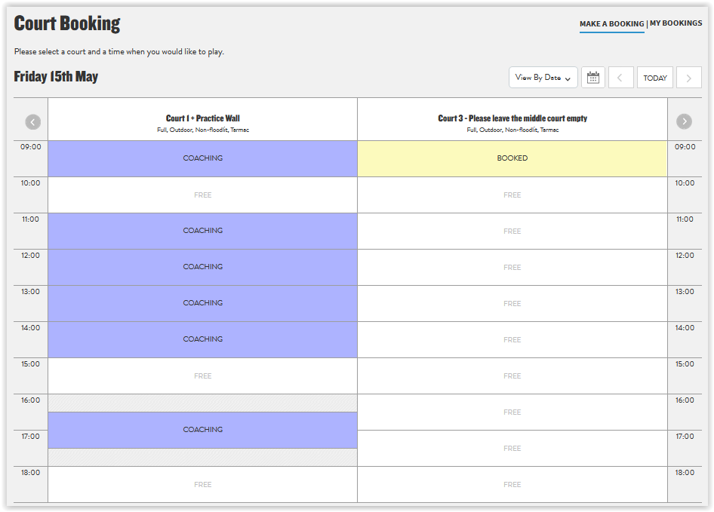

Matt Last and David Lewis are the administrators of the system and will have full visibility of who has booked each court and should contacted if there are any queries.

To make a new booking go to a screen (as described above) that shows the Date and Time required.

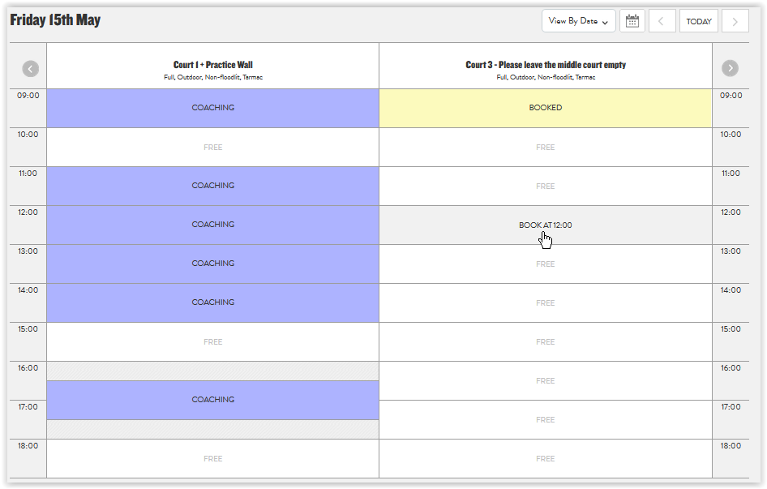

And click on the session required.

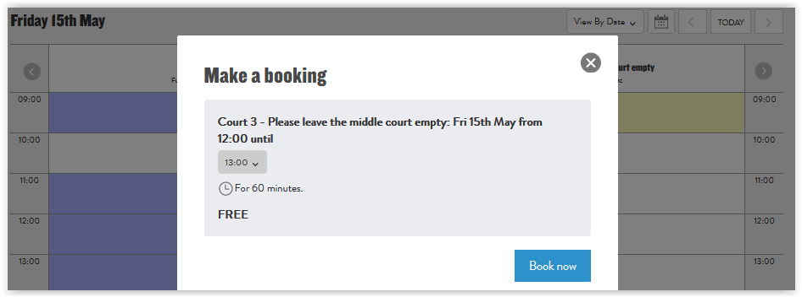

Then click on the Book Now button.

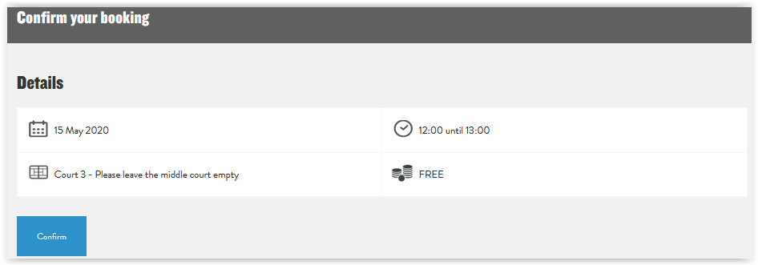

Then click on the Confirm button.

The Confirmation screen will then be displayed and an email sent to your registered email address.

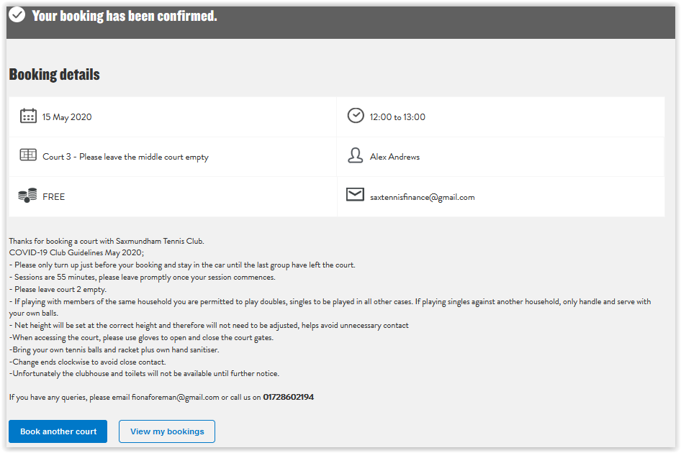

You may book another court on another day or view your current bookings.

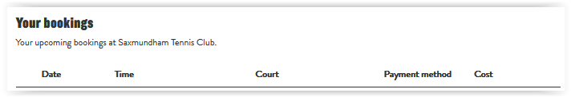

To Cancel a Booking click on the Cancel option

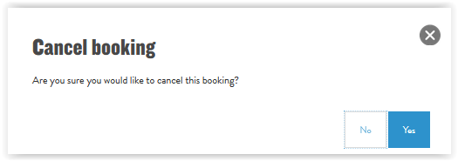

And click on the Yes option to Cancel

The session will then display in your Bookings as Cancelled

Although there are no charges for making a booking it is essential to cancel any unwanted sessions as others may want to play at that time.

Matt or another Committee member will be around to open up the courts at 9:00 and close them at 19:00 and set the net height correctly for the day.

If there are no early or late bookings, we will use our discretion and may delay opening or close early so it is essential that you use the booking system if you intend to play.

We have implemented the booking system to maintain control in these unusual times and give everyone visibility of availability and eliminate unnecessary journeys.

You will need to be a member to book but we have deliberately allowed members to play with other family members they are living with who may not, at the moment, be members and we hope that they will be encouraged to join when normal playing is resumed.

Rather than formal Guest Fees being requested, we are leaving this to the discretion of the member to make a voluntary donation, preferably by bank transfer to the following account:

Account name: Saxmundham Tennis Club
Sort code: 40-40-20
Account No.: 40724734

giving the member’s surname, followed by “Guest Fee” in the reference field.

